**Department of Artificial Intelligence**

**College of Computer Science and Information Technology**

***Prototypes by Using Figma***

1. **Objectives**

This lab focuses on the interaction and prototyping capabilities in Figma, building on the design basics from the previous lab. By the end of this lab, students will:

* Understand how to create interactive prototypes using Figma mockups.
* Learn how to simulate user interactions such as navigation, button clicks, and transitions.
* Apply HCI principles to enhance user experience through effective interactions.

**Lab Requirements**

Software: Software: Figma (Free Online Tool: [Figma.com](https://figma.com))

1. **Explanation of Key Concepts**

*  **Figma Prototyping:**

Figma allows designers to create interactive prototypes by linking different frames (screens) and adding animations, transitions, and other interactive elements to simulate how users would interact with the design.

* **Interactions:** Actions like clicks or hovers that trigger navigation between frames or other responses.
* **Transitions:** The visual effects that occur when moving from one screen to another (e.g., slide, dissolve).
* **Triggers:** Events like button clicks or swipes that activate transitions between frames.

**Usability in Prototypes:**

When creating prototypes, consider how users will navigate and interact with the interface. User experience can be enhanced by clear, intuitive interactions, smooth transitions, and responsive feedback.

**Example:**





**Example in Figma:**

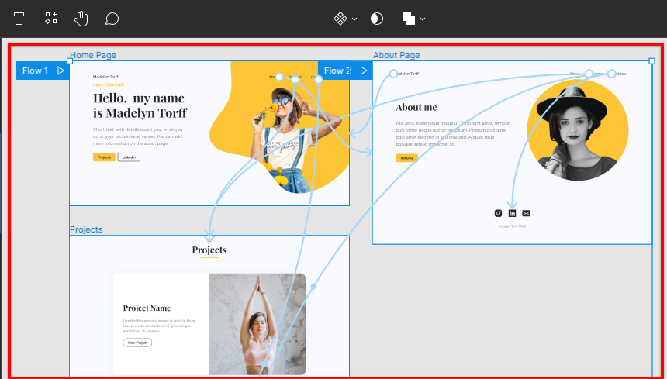

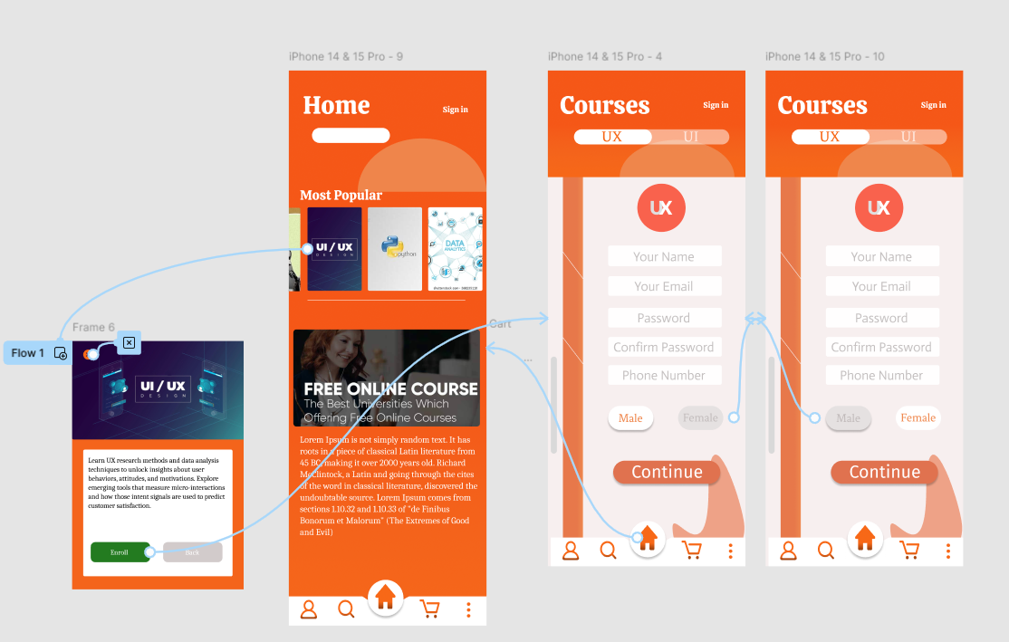

1. **Activities**

* **Exercise 1: Interactive Mockup for Online Course Enrollment Page**

**Task 1**:

Creating an Interactive Mockup Creating an Interactive Mockup.

Step 1: Return to the mockup for the Online Course Enrollment Page from the previous lab and copy the frame of the mockup.

Step 2: Create a new page (Page 2) in your Figma file and paste your mockup there.

Step 3: Set the name of this page to “Lab 5”

Step 4: Add some interactive elements:

* + Select a button/link (e.g., "Submit" or "Enroll Now", ”More details”) on your mockup.
  + Click the "Prototype" tab in Figma.
  + Link the button/ link to the Course Description mockup frame by dragging the connector to that frame.
  + Set the interaction trigger (e.g., On Click).

Step 5: Incorporate different types of interactions in your mockup:

* + Use hovering effects to highlight elements when the mouse is over them.
  + Create overlays that display additional information when interacting with specific components.
  + Ensure that these interactions enhance the user experience and align with HCI principles.

Step 6: Create a frame for a "Confirmation Page" that appears after viewing the Course Description. Include elements such as a confirmation message (e.g., "You have successfully enrolled in [Course Name]!"), a brief summary of the course, and a button (e.g., "Go to Dashboard" or "View Courses") that links back to the Online Course Enrollment Page or another relevant section.

* **Exercise 2: Your Favorite Dishes**

**Task: 2**

Complete the class activity on your favorite dishes.

Step 1: Create a new design file name it to “Lab 5 – Ex2 – Your ID”

Step 2: Create a Mockup of Your Favorite Dishes Create a Mockup of Your Favorite Dishes.

* Design a mockup showcasing a list of your favorite dishes with names, brief descriptions, and images.

Step 3: Create a Recipe Mockup

* Choose one dish from your list and create a detailed recipe mockup, including ingredients, preparation steps, and a photo that can be enlarged.

Step 4: Connect the Mockups

* Link the dishes mockup to the recipe mockup using relevant interactions, such as clicking on a dish name or image to view the recipe.

1. **Submission**

After completing your interactive prototype, share the Figma link as follows:

1. Click on **Share** in Figma.
2. Copy the link and paste it below.



**Add Your Figma Links Here:**

1. **References**

Figma Interactive Design Example: <https://youtu.be/v1UKB-0EUhQ?si=hrtqZJx4bMJkJs_B>